For Official Release
PR 001-09222021
Office of the Governor
Utulei, American Samoa
September 22nd, 2021
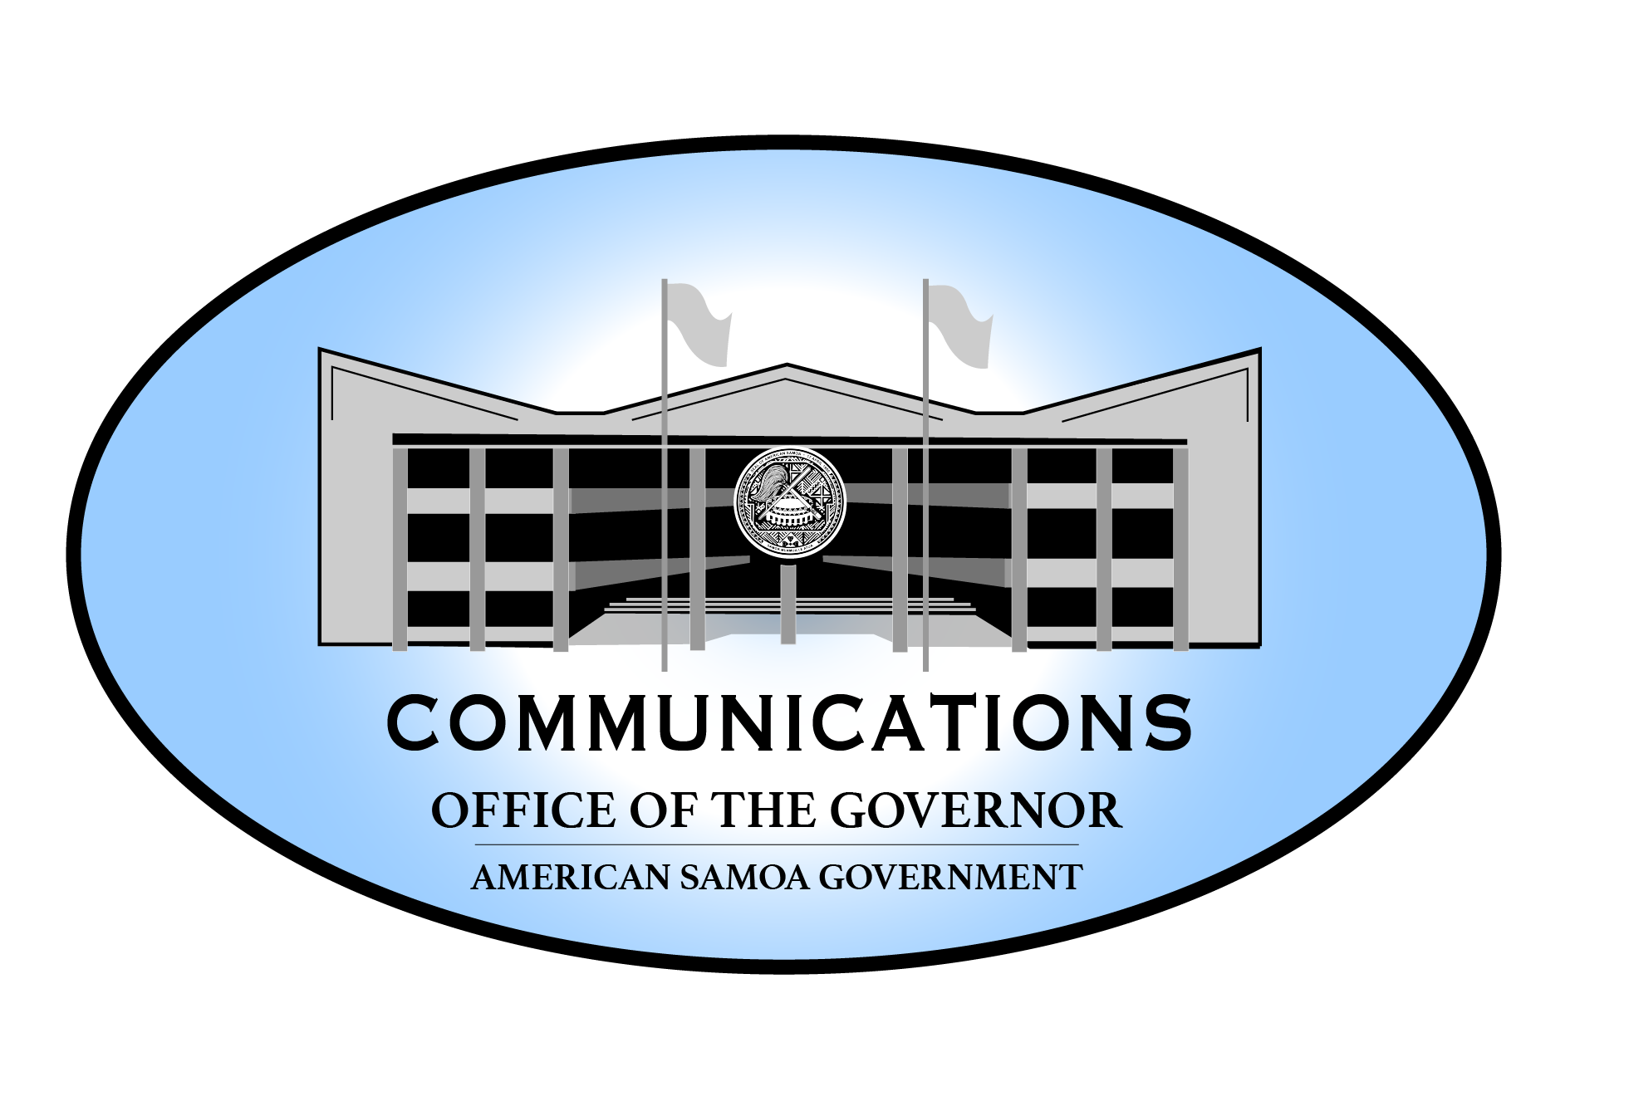
“Governor Confirms the Change in
Commercial Flight Schedule.”
"How can we incorporate the safest travel system possible that will fit American Samoa, which will ultimately set us up to open up our borders responsibly?”
“This first positive case is an example of how well the Safe Travels American Samoa initiative is at work, as well as the prescreening of the TALOFAPASS system, gives me hope that we are moving in the right direction..“

The request for a change in Hawaiian Airlines future flight schedule has been approved by Hawaiian Airlines CEO Mr. Peter Ingram.

"The GAR has consulted me on recent discussions by the COVID-19 Task Force meetings, and I commend them with their hard work and diligence in keeping our shores with the least among of COVID cases as possible. It was not an easy decision to make, and I humbly ask for everyone's patience and support as we make a slight change to the travel plans for the Territory," stated Governor Lamanu.

Governor Lemanu continued, "Each flight is an opportunity to learn more about how we can incorporate the safest travel system possible that will fit American Samoa, which will ultimately set us up to open up our borders responsibly. I want to personally thank Mr. Ingram for all his hard work and dedication of service to American Samoa. The Taskforce discussed and considered many factors from various scenarios presented to the GAR, such as traveler experience and the impacts to the traveler accommodation as well as the airline business side. We understand this will cause some frustration. However, we need to err on the side of caution. Understand that our limited resources and capabilities to respond to an overwhelming surge will not be in our favor. This first positive case is an example of how well the Safe Travels American Samoa initiative is at work, as well as the prescreening of the TALOFAPASS system, gives me hope that we are moving in the right direction. At the same time, it has opened up our eyes to our vulnerabilities."

Governor Lemanu had requested a proposed updated schedule of flights for the remainder of the year in a letter dated September 21, 2021, to Hawaiian Airlines CEO Mr. Peter Ingram. The reason stated was that "...we have determined that separating flights by only 14 days taxes our ability to quarantine people in American Samoa."

The new dates for flights are October 14, November 1, November 18, and December 6. Two fewer flights from the original schedule that was approved previously.

The GAR had briefed the Governor on possible options that DOH and the EOC believed would help American Samoa navigate these uncharted times while maintaining the least amount of COVID cases in the Territory. After careful consideration, the Governor decided to ask Hawaiian Airlines to update their schedule.

The Hawaiian Airlines flight scheduled for September 27 is still expected to arrive on schedule. There is no change to this plan.

###

